|  |  |  |  |  |  |  |  |  |
| --- | --- | --- | --- | --- | --- | --- | --- | --- |
| |  | | --- | | Samsung Q-SOUNDBAR Q700B/XV soundbar | | D:\_TUMA SOUND\Hi Fi sound\19_2_54.jpg |  |  |  |  |  | | --- | --- | --- | --- | | D:\_TUMA SOUND\Hi Fi sound\24_61.jpg | D:\_TUMA SOUND\Hi Fi sound\22_2_39.jpg | D:\_TUMA SOUND\Hi Fi sound\20_2_51.jpg |  | |  | **Featured information**   * Wireless Dolby Atmos surround sound technology helps enjoy ultimate music. * Total speaker power up to 330 W delivers vibrant and explosive sound quality * Q-Symphony technology helps synchronize with TV speakers for a perfect listening experience * Very diverse connection with other devices through HDMI, WiFi, Bluetooth communication ports.   **Price: 400$**  **Specifications:**   * **Power capacity:** 330 W * **Bluetooth:** Yes * **Audio technology:** Q-Symphony, Acoustic Beam * **Weight:** 5.9 kg |

**Description:**

#### **Samsung Q-Soundbar Q700B/XV Soundbar - Vivid sound**

Samsung Q-Soundbar Q700B/XV sound bar was launched in 2021 from the Korean brand, is owned by many people with stable quality, diverse sound colors that catch listeners' ears, will help you solve problems. relieve stressful times. Promises to be a valuable speaker

#### **Simple design with many modern technologies**

The Samsung Q-Soundbar Q700B/XV speaker is dressed in an attractive and powerful black color, combining with any outdoor or indoor space. Suitable for places with classic to modern designs. There is also a sturdy, sturdy shell made from plastic and metal. The speaker is also easy to disassemble for cleaning.

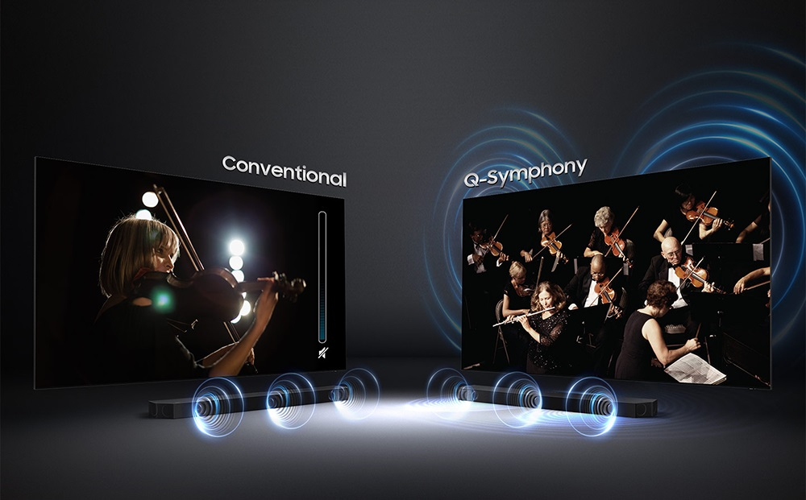

The bar speaker is designed by the manufacturer with a soundbar audio system, which will have up to 8 speakers combined with a wireless speaker device. Helps you place it in any position you want to experience attractive melodies.

#### **Diverse connection system and remote intelligent control**

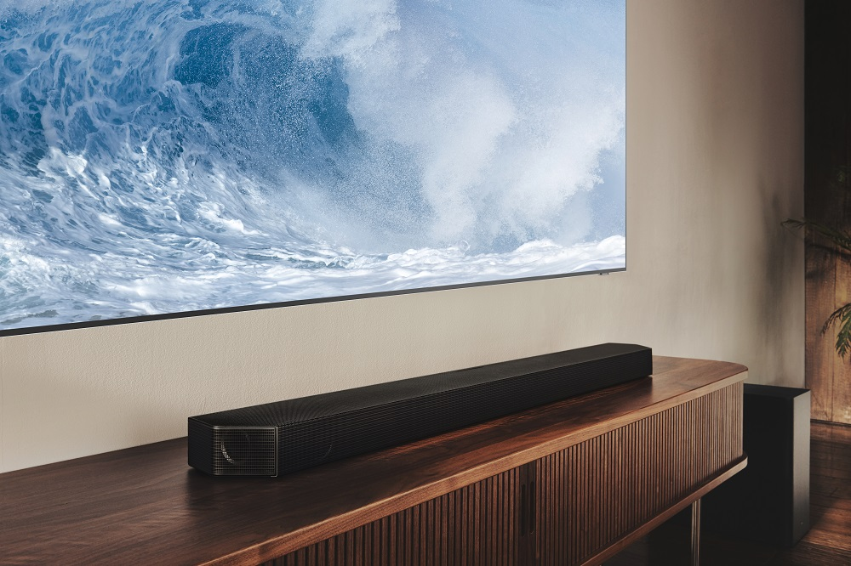

The Samsung HW-Q700A soundbar can be connected to a variety of TV devices or HDMI, wifi, and Bluetooth ports. Furthermore, this sound bar can be connected to a handheld gaming device, helping users to be satisfied with the vivid sound of games.

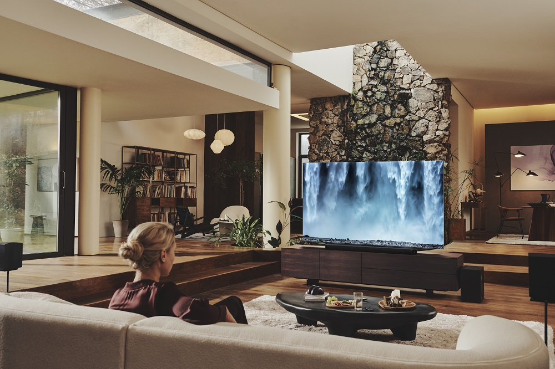

The speaker device comes with a remote, you can set it up to your liking and connect it to your smartphone for control from further places. Convenient for you to adjust when doing other jobs.